## S.2.3 Correlation matrices for the different taxonomic groups

## *Figure S.2.3.1: Pairwise posterior distributions for trait covariations (slopes of the linear regressions) within Araneae. Column names represent independent variables, while row names denote dependent variables Negative covariations are highlighted in red and positive covariations in blue. Effect sizes that are clearly determined (i.e. the 95% interval does not include zero) are outlined in the corresponding colour. Icon at the top: Spider by Matthew Davis from Noun Project (CC BY-NC-ND 2.0).*

**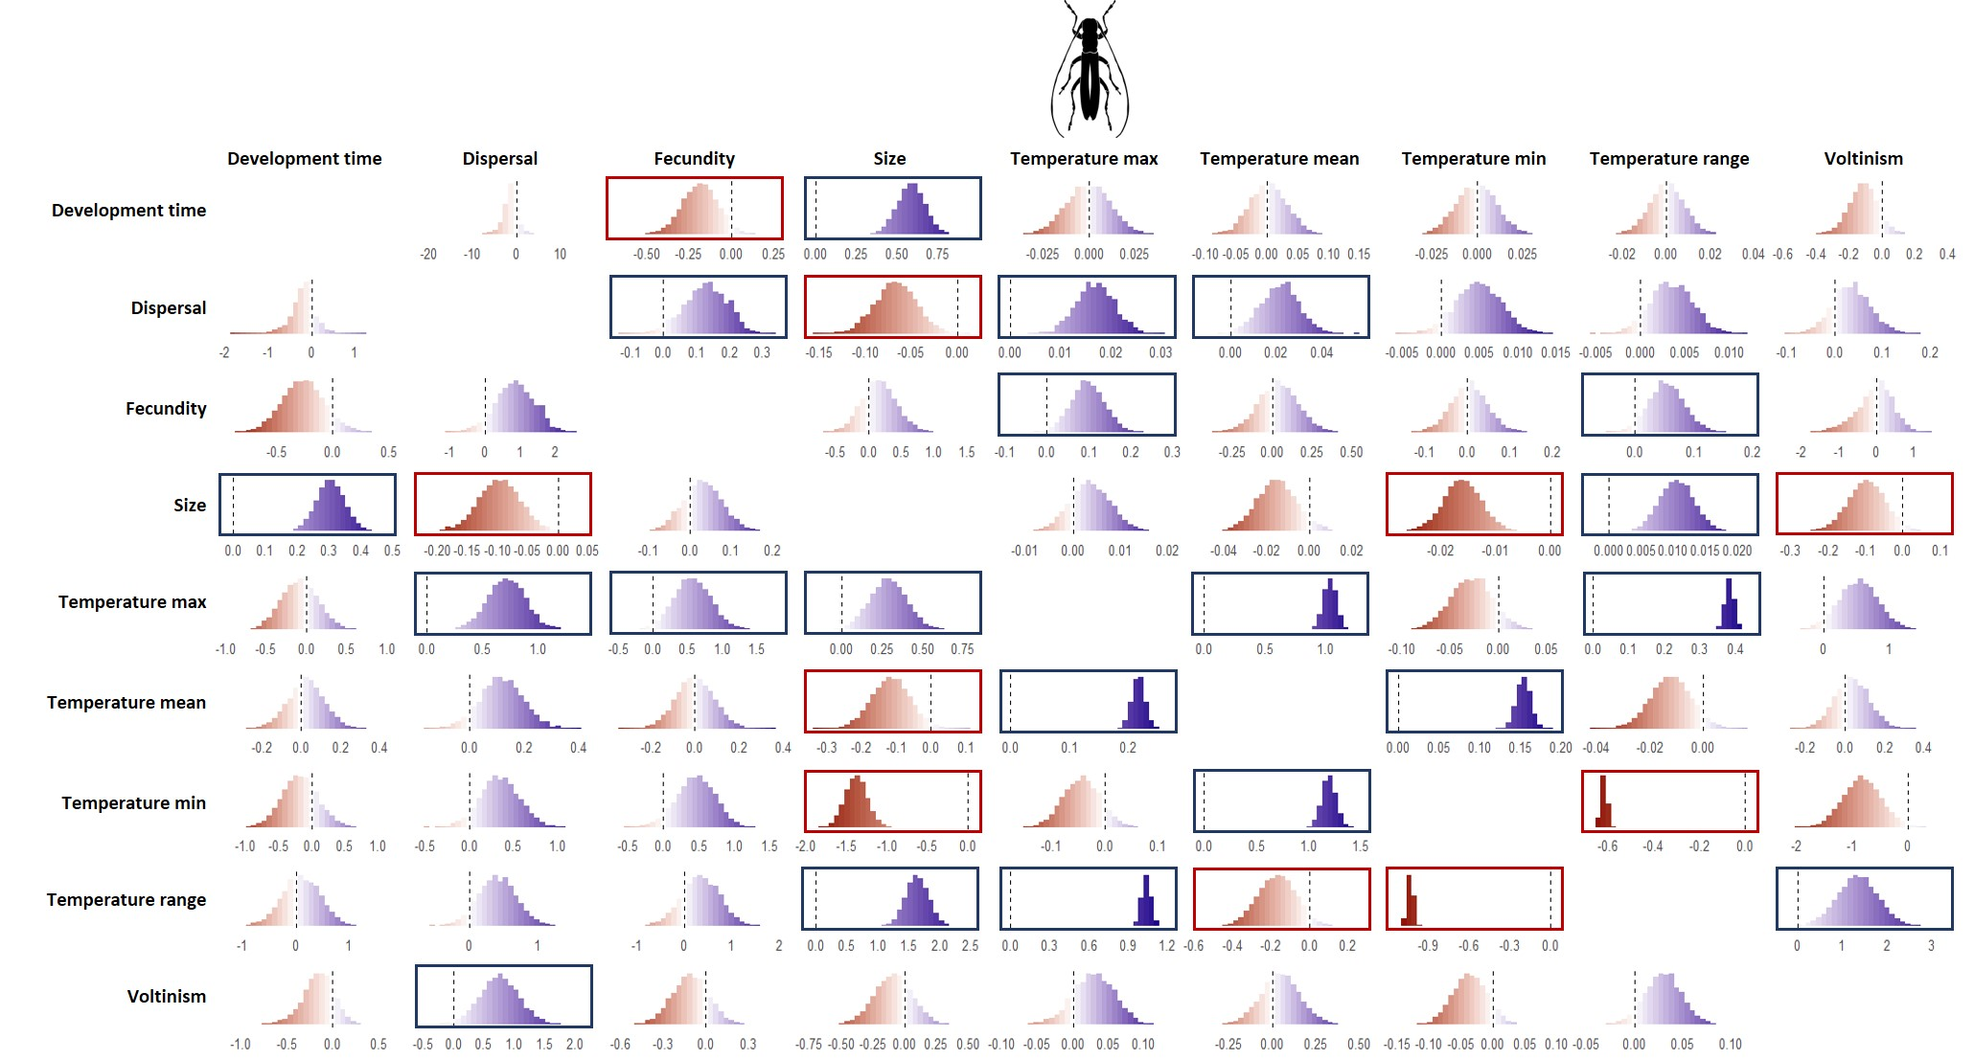***Figure S.2.3.2: Pairwise posterior distributions for trait covariations (slopes of the linear regressions) within Coleoptera. Column names represent independent variables, while row names denote dependent variables Negative covariations are highlighted in red and positive covariations in blue. Effect sizes that are clearly determined (i.e. the 95% interval does not include zero) are outlined in the corresponding colour. Icon at the top: Beetle by Rachel Siao from Noun Project (CC BY-NC-ND 2.0).*

## *Figure S.2.3.3: Pairwise posterior distributions for trait covariations (slopes of the linear regressions) within Hemiptera. Column names represent independent variables, while row names denote dependent variables Negative covariations are highlighted in red and positive covariations in blue. Effect sizes that are clearly determined (i.e. the 95% interval does not include zero) are outlined in the corresponding colour. Icon at the top: Cicada by Alejandro Capellan from Noun Project (CC BY-NC-ND 2.0).*

## *Figure S.2.3.4: Pairwise posterior distributions for trait covariations (slopes of the linear regressions) within Hymenoptera. Column names represent independent variables, while row names denote dependent variables Negative covariations are highlighted in red and positive covariations in blue. Effect sizes that are clearly determined (i.e. the 95% interval does not include zero) are outlined in the corresponding colour. Icon at the top: wasp by parkijsun from Noun Project (CC BY-NC-ND 2.0).*

## *Figure S.2.3.5: Pairwise posterior distributions for trait covariations (slopes of the linear regressions) within Isopoda. Column names represent independent variables, while row names denote dependent variables Negative covariations are highlighted in red and positive covariations in blue. Effect sizes that are clearly determined (i.e. the 95% interval does not include zero) are outlined in the corresponding colour. Icon at the top: isopod by Pham Thanh Lôc from Noun Project (CC BY-NC-ND 2.0).*

## *Figure S.2.3.6: Pairwise posterior distributions for trait covariations (slopes of the linear regressions) within Lepidoptera. Column names represent independent variables, while row names denote dependent variables Negative covariations are highlighted in red and positive covariations in blue. Effect sizes that are clearly determined (i.e. the 95% interval does not include zero) are outlined in the corresponding colour. Icon at the top: Moth by parkijsun from Noun Project (CC BY-NC-ND 2.0).*

## *Figure S.2.3.7: Pairwise posterior distributions for trait covariations (slopes of the linear regressions) within Odonata. Column names represent independent variables, while row names denote dependent variables Negative covariations are highlighted in red and positive covariations in blue. Effect sizes that are clearly determined (i.e. the 95% interval does not include zero) are outlined in the corresponding colour. Icon at the top: Dragonfly nu Hermine Blanquart from Noun Project (CC BY-NC-ND 2.0).*

## *Figure S.2.3.8: Pairwise posterior distributions for trait covariations (slopes of the linear regressions) within Orthoptera. Column names represent independent variables, while row names denote dependent variables Negative covariations are highlighted in red and positive covariations in blue. Effect sizes that are clearly determined (i.e. the 95% interval does not include zero) are outlined in the corresponding colour. Icon at the top: Cricket by Ed Harrison from Noun Project (CC BY-NC-ND 2.0)*